AJ Windows and Doors
01304 619907
ajwindowsanddoors@yahoo.com

Residence collection
R9/R7/R2
UPVC with a touch of class

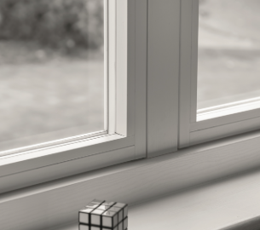

Residence R2
- 100mm Frame Depth
- 9 Chambers
- Always square internal bead
- Flush Sash Only
- Mechanical Bead
- Clean Lines and superb performance

Residence R2s
- As above
- Seamless
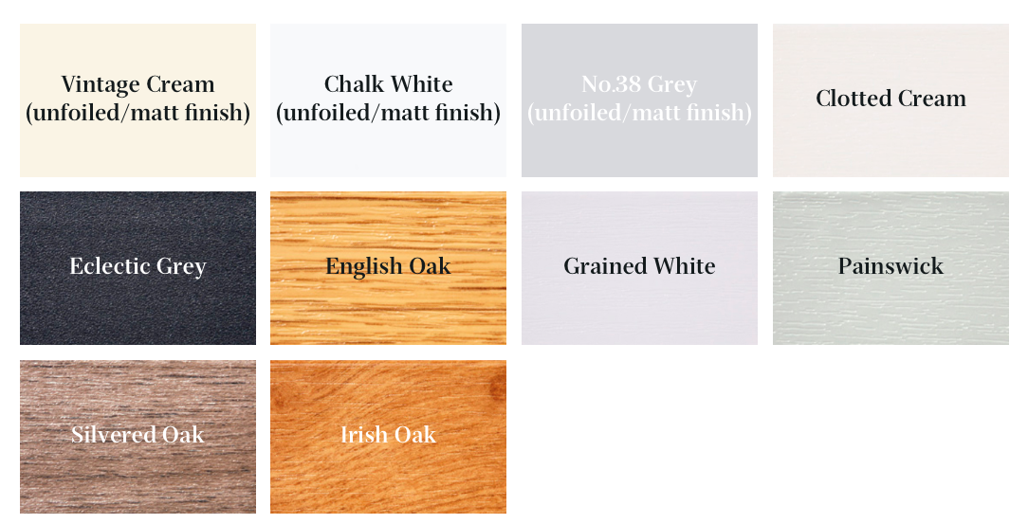
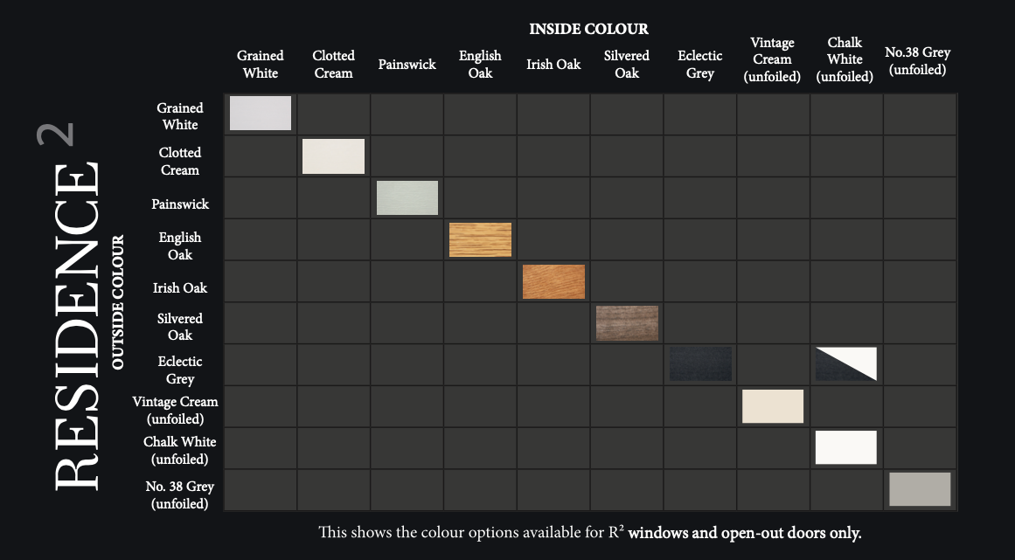

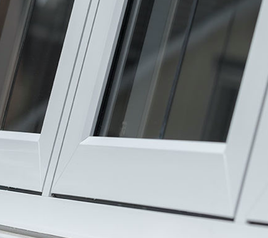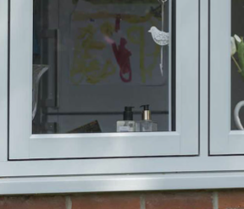
Residence R7
- 75mm Frame Depth
- 7 Chambers
- Always flush internally
- Mechanical
- Three internal bead styles square/decorative or staff

Residence R7s
- As above
- Seamless Weld

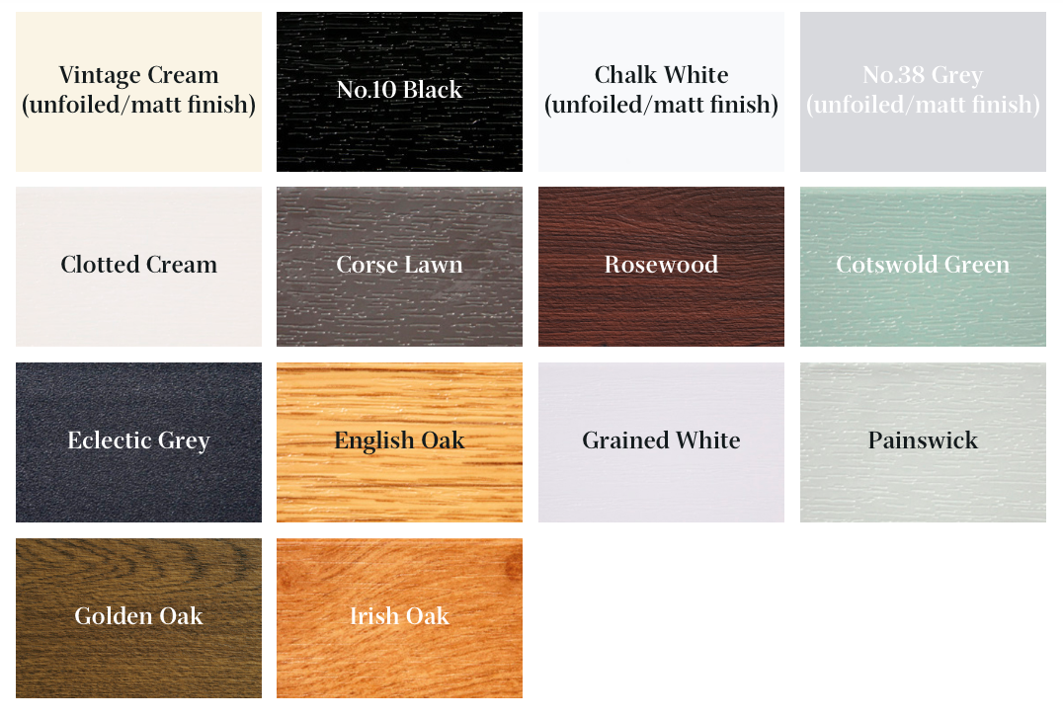
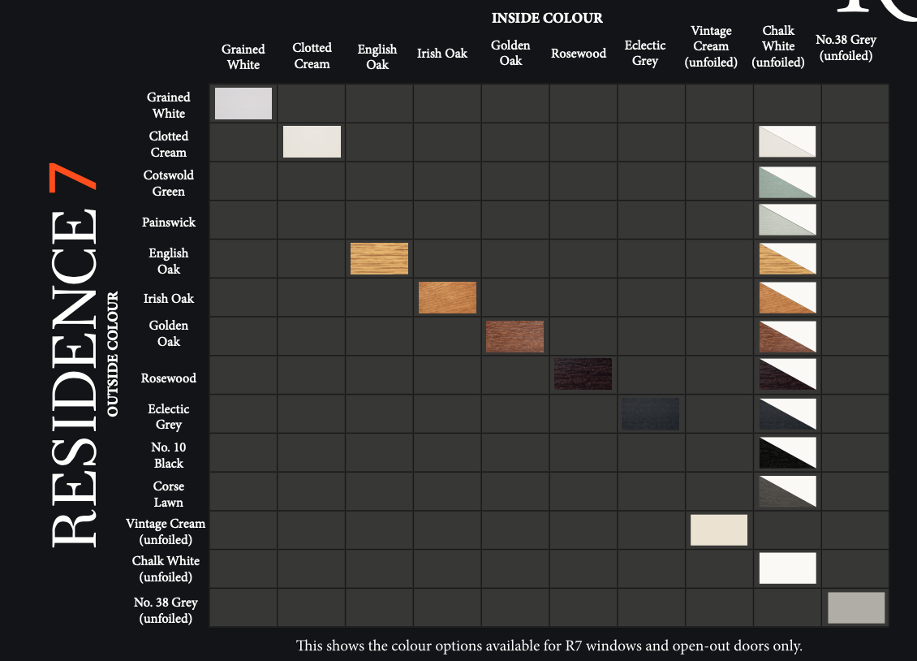

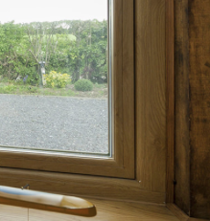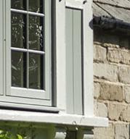

Residence R9
- 100mm Frame Depth
- 9 Chambers
- Always Decorative internally
- Mechanical

Residence R9s
- As above
- Seamless Weld

